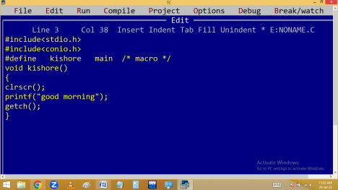
printf(): It is the major predefined output function in C, available in stdio.h 🡺 Standard Input Output Header file.
Printf always refers standard output device i.e. monitor. Syntax:
int printf(“[text] [conversion characters/format specifiers] “ [, variables ] [ , expressions ] );
Note:
1. Printf always return int that indicate the no of visible / printable characters in “ “.
2.In printf execution order right to left but printing is left to right.
3.In printf the first argument should be in “ “. 4.In printf everything printed as it is except back slash characters and conversion characters.
5. Printf can perform both formatted and unformatted outputs.
Example: Write a C program to find string length without using strlen() or a loop.
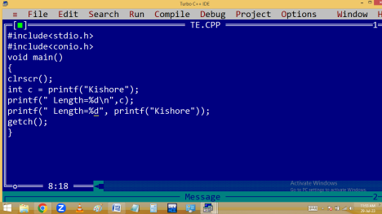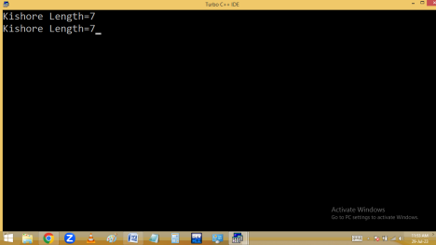
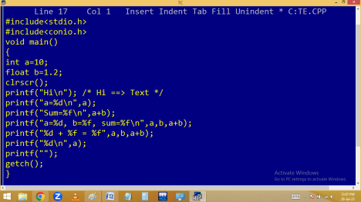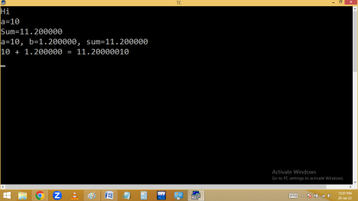
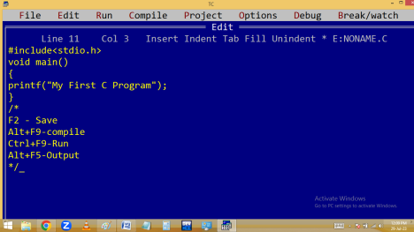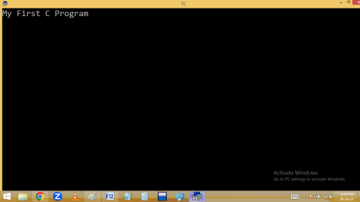
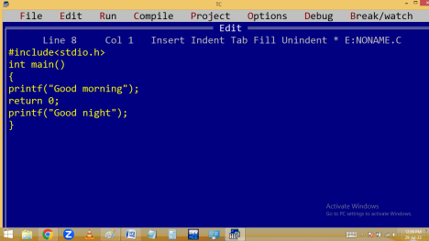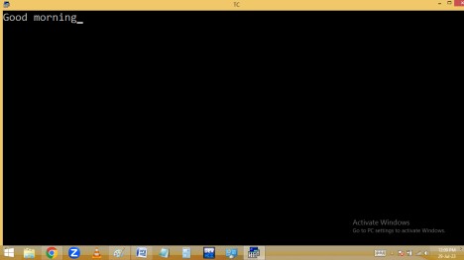
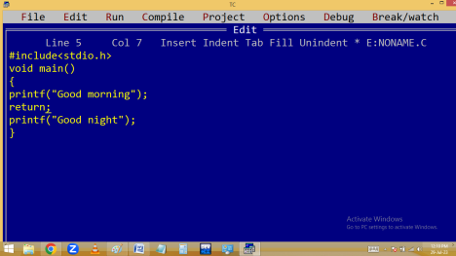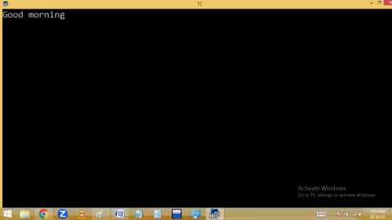
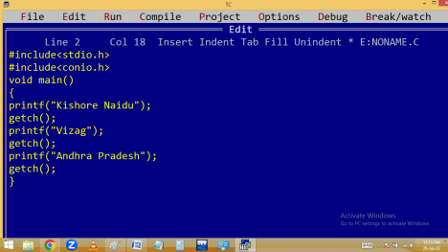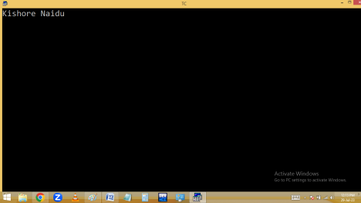
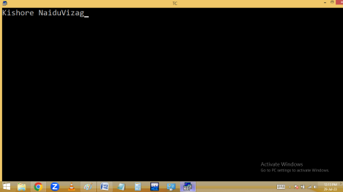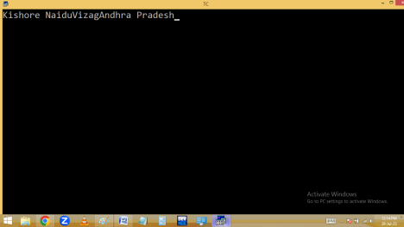
In Dev C++:
#include<stdio.h>
#include<conio.h>
#include<stdlib.h>
main()
{
printf("Kishore Naidu"); getch();
system("cls");
printf("Vizag");
getch();
system("cls");
printf("Andhra Pradesh"); getch();
}
BACK SLASH / ESCAPE SEQUENCE CHARACTERS They started with back slash [ \ ].
They used to format the outputs.
They participated in program execution but not displayed in output. Hence they are also called escape sequence characters.
Each back slash character=1 byte i.e. one character.
BACK SLASH CHARACTER | DESCRIPTION
\a | Alert [ beep sound ]

\b | Back space
\n | New line character
\t | Tab space
\r | Carriage return[beginning of line]
\f | Form feed
\v | Vertical tab
\0 | Null char
\\ | \ [ invalid ]
\k | k [ invalid ]

